Modeling and Automated
Containment of Worms

Scope of the Project

In this project we are going model a worm and show the propagation of worms. Then we design a containment which is automated and it is used to contain the spreading of worms beyond its early stages. Thus this project can be used understand the worm propagation. This can be useful to design an Antivirus technique to contain worms. Thus our project can be used in the domain of Network Security.

Introduction

The goal of our research is to provide a model for the propagation of random scanning worms and the corresponding development of automatic containment mechanisms that prevent the spread of worms beyond their early stages. This containment scheme is then extended to protect an enterprise network from a preference scanning worm. A host infected with random scanning worms finds and infects other vulnerable hosts by scanning a list of randomly generated IP addresses. Worms using other strategies to find vulnerable hosts to infect are not within the scope of this work. Some examples of nonrandom-scanning worms are e-mail worms, peer-to-peer worms, and worms that search the local host for addresses to scan.

In this paper, we propose a stochastic branching process model for the early phase of worm propagation. We consider the generation-wise evolution of worms, with the hosts that are infected at the beginning of the propagation forming generation zero. The hosts that are directly infected by hosts in generation n are said to belong to generation n þ 1. Our model captures the worm spreading dynamics for worms of arbitrary scanning rate, including stealth worms that may turn themselves off at times.
We show that it is the total number of scans that an infected host attempts, and not the more restrictive scanning rate, which determines whether worms, can spread. Moreover, we can probabilistically bound the total number of infected hosts. These insights lead us to develop an automatic worm containment strategy. The main idea is to limit the total number of distinct IP addresses contacted (denote the limit as MC) per host over a period we call the containment cycle, which is of the order of weeks or months. We show that the value of MC does not need to be as carefully tuned as in the traditional rate control mechanisms. Further, we show that this scheme will have only marginal impact on the normal operation of the networks. Our scheme is fundamentally different from rate limiting schemes because we are not bounding instantaneous scanning rates. Preference scanning worms are a common class of worms but have received significantly less attention from the research community. Unlike uniform scanning worms, this type of worm prefers to scan random IP addresses in the local network to the overall Internet. We show that a direct application of the containment strategy for uniform scanning worms to the case of preference scanning worms makes the system too restrictive in terms of the number of allowable scans from a host. We therefore propose a local worm containment system based on restricting a host’s total number of scans to local unused IP addresses (denoted as N). We then use a stochastic branching process model to come up with a bound on the value of N to ensure that the worm spread is stopped.

Modules of the Project

- User Interface Design
- Worm Propagation Model
- Scanning for worms
- Detecting and categorizing worms
- Containment of worms

Module Description
User Interface Design
In this module we have designed the user interface for all the hosts. We design the user interface to show our propagation of worms in a graphical manner or GUI. By showing the output in GUI gives more attractive and understandable to everyone. Then we design the containment window to show the scanning, detection of worms. Thus we design the whole user interface in this module.

Worm Propagation Model
In this module, we create a worm spreading model. This model is designed for the propagation of worms inside a network. Inside the network we spread the worms in a controlled environment. To create worm propagation model we need to form a network by using the server socket class and socket class available in Java. These two classes are used to create a connection to transfer data from a host to other host inside a network.
Scanning for worms
Our strategy is based on limiting the number of scans to dark-address space. The limiting value is determined by our analysis. Our automatic worm containment schemes effectively contain both uniform scanning worms and local preference scanning worms, and it is validated through simulations and real trace data to be non-intrusive.

Detecting and categorizing worms
The model is developed for uniform scanning worms and then extended to preference scanning worms. We detect these two worms and categorize it in this module.

Containment of worms
This model leads to the development of an automatic worm containment strategy that prevents the spread of a worm beyond its early stage. Specifically, for uniform scanning worms, we are able to 1) provide a precise condition that determines whether the worm spread will eventually stop and 2) obtain the distribution of the total number of hosts that the worm infects.
UML Diagrams
Use Case Diagram
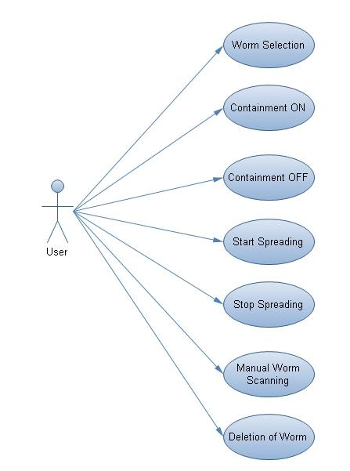

Class Diagram

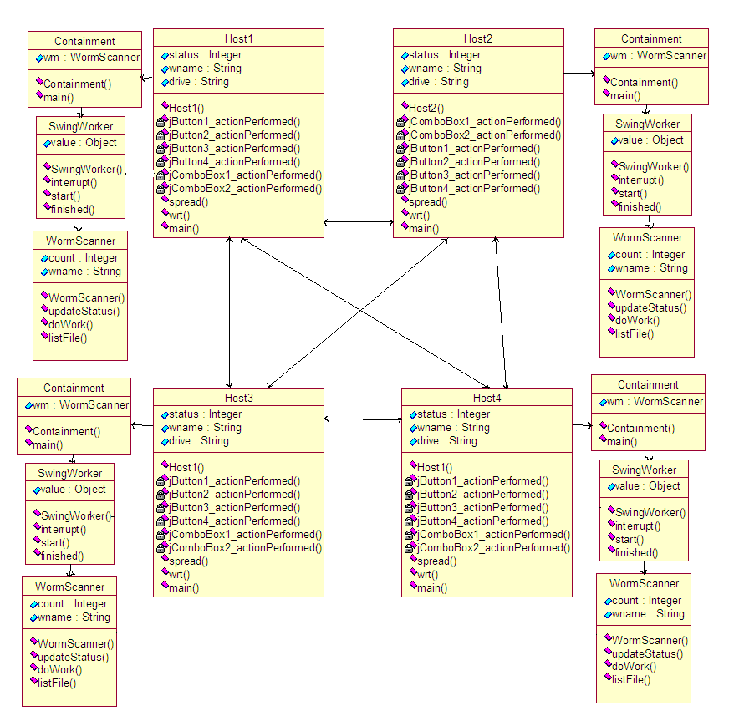

State Diagram

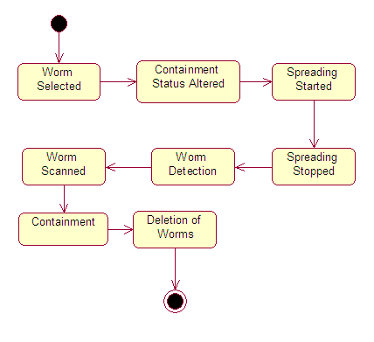

Activity Diagram

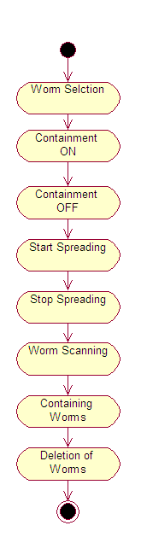

Sequence Diagram
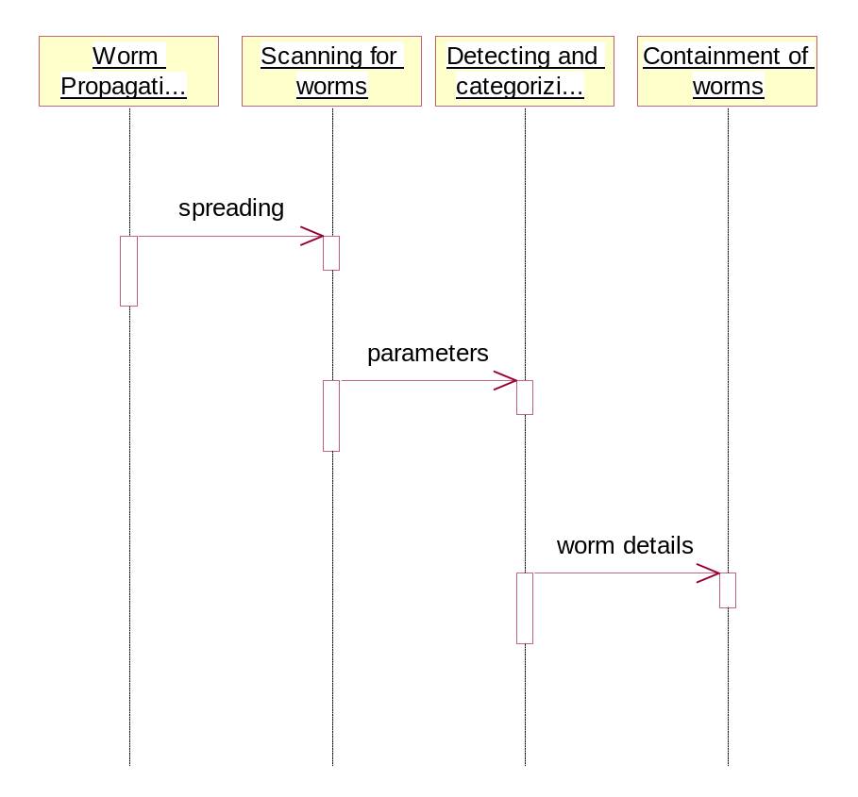
Collaboration Diagram

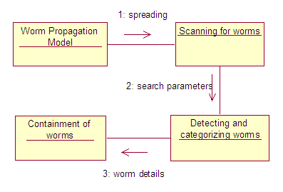

Component Diagram

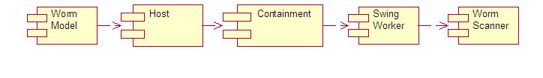

Data Flow Diagram
Host 1
Host 2
Host 3
Host 4
Worm Spreading
Worm Scanner
Containment
Worm Scanner
Containment
Worm Scanner
Containment
Worm Scanner
Containment

System Architecture

Modeling and Automated Containment of Worms
Worm Model
Containment On
Automatic Worm Scanning
Manual Worm Scanning
Containment OFF
Starting Propagation
Stopping Propagation
Containment

References

[1] CAIDA, “CAIDA Analysis of Code-Red,”
http:// www.caida.org/analysis /security/code-red , 2007.

[2] “The Cost of Code Red: $1.2 Billion,” USA Today News,
http://www.usatoday.com/tech/news/2001-08-01-code-red-costs.htm,2001.

[3] Cisco Documentation, “Configuring Port Security,”
http://www.cisco.com/univercd/cc/td/doc/product/lan/cat6000/12_1e/swconfig/port_sec.htm, 2007.

[4] H. Andersson and T. Britton, “Stochastic Epidemic Models and
Their Statistical Analysis, ” Lecture Notes in Statistics, vol. 151, 2000.

[5] J. Bartiomiejczyk and M. Phipps, Preventing Layer 2 Security Threats,
http://searchnetworking.techtarget.com/tip/0,289483,sid7_gci1009100,00.html, 2007.

Technique used

We now present the branching process model we use to characterize the propagation of random scanning worms. Scanning worms are those that generate a list of random IP addresses to scan from an infected host. The uniform scanning worms are those in which the addresses are chosen completely randomly while preference scanning worms weigh the probability of choosing an address from different parts of the network differently. In this paper, we first describe the approach for uniform scanning worms, and then, we present the extension for preference scanning worms. In our model, a host under consideration is assumed to be in one of three states: susceptible, infected, or removed. An infected host generates a list of random IP address to scan. If a susceptible host is found among the scans, it will become infected. A removed host is one that has been removed from the list of hosts that can be infected.

Advantages

Our strategy can effectively contain both fast scan worms and slow scan worms without knowing the worm signature in advance or needing to explicitly detect the worm. Using the branching process model, we are able to provide a precise bound on the total number of scans that ensure that the worm will eventually die out. Further, from our model, we also obtain the probability that the total number of hosts that the worm infects is below a certain level, as a function of the scan limit. In this scheme, we restrict the total number of scans per host to the dark-address space. We derive the precise bound N on the total number of scans to the dark-address space, which ensures that the worm will be contained.

Applications

Containing the worms can be applied in any networks to contain the worms. Because worms will not allow the network give its full performance. It degrades the network’s performance. It will use the network for its propagation. Thus in order to use the network efficiently and effectively we need to contain the propagation of worms inside our network. Thus containment of worms can be used in office networks, military networks, etc. Generally it can be used in any networks to avoid worm propagation.

